C Group Study Guide
General Department Info
- Long Beach Junior Lifeguards Founded in 1969 by Dick Miller and Pat Flynn
- Commanding Officers
  - Marine Safety Chief: Chief Medina
  - Marine Safety Captains: Captain Naranjo (JG Captain/Admin Captain), Captain Guerra, Captain Dixon, Captain Abel
  - LBJG Program Coordinator: Sergeant Farnell
- Long Beach Lifeguard Headquarters (Beach Ops) is located on West Beach
- Junior Lifeguard Headquarters is located behind Claremont lifeguard tower
- Lifeguard substations:
- Bayshore
- Marine Park
- Colorado Lagoon
Lifeguard Basics
- Basic Rule: always carry your rescue buoy
- Primary Rule: always watch the water
- If you don’t know? GO!
- Rescue buoys can hold 1-3 non-hysterical people in the water
  - Swim head-up freestyle towards victim, keeping visual contact with the victim
  - Swim backstroke to shore, ensuring victim makes it to shore with you
  - If a victim starts climbing the line of the buoy towards you, slip out of the harness and ensure victim does not grab hold of you
- Rescue board: used in long distance rescues
- Boat Rescue: bowline knots are used during boat rescues to attach the line of the rescue buoy to a cleat on the boat.
- Pier Rescues: a pier jump may be the fastest way to get to the victim.
  - Water must be deep enough to perform a pier rescue
  - Perform a spoon dive when doing a pier jump, it will slow you down and stop you from going too deep
- Jetty Rescue: a jetty jump may be the fastest way to get to the victim.
  - Never run on the jetty, even during a rescue!- it is slippery and the rocks are uneven
  - Be sure to pick an entry point that is clear of underwater rocks
  - A belly flop is used during a jetty jump to make sure the dive is shallow. Try to keep your head up to keep visual of the victim
- Potential Beach Hazards: the following list is a few examples of beach hazards that lifeguards talk to beachgoers about
  - Stingrays (stingray shuffle)
  - Drop-offs
  - Dogs
  - Kite Surfers
  - Broken glass
- Codes:
  - Code 3: emergency response= Lifeguard trucks will drive with lights and sirens on
    - All JGs should not try to run out of the way, instead stop and take a knee
    - “Code 3, take a knee”
  - Code 4: used when LG wants to communicate that they don’t need help
    - “No further assistance needed”
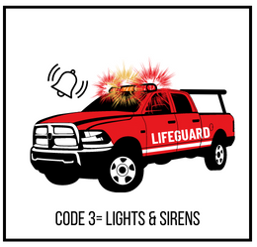
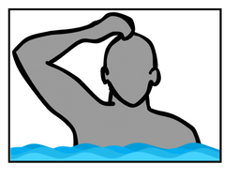
    - Can be communicated by putting your hand in a fist and placing on top of your head, creating a circle with your arm
First Aid
Code 4 signal
- Types of Wounds
  - Abrasion: A scrape on the surface of the skin, superficial scrape
  - Laceration: A jagged cut
  - Incision: clean, straight cut (most likely caused by knife)
  - Avulsion: a cut that creates a flap of skin
  - Puncture: deep, penetrating would cause by a pointed object
  - Contusion: bruising
  - Amputation: complete removal or body part
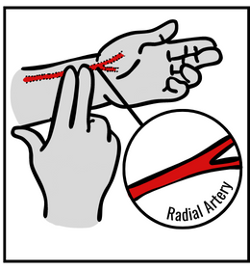
- How to help someone that is bleeding
- Put on sterile gloves
- Apply direct pressure with a sterile dressing/bandage
- Elevate injury if possible
- Continuing adding layers of bandage until bleeding stops
- Vitals: lifeguards will need to take patient’s vitals to monitor their airway, breathing, and circulation (ABC’s)
  - Pulse: how fast a person’s heart is beating
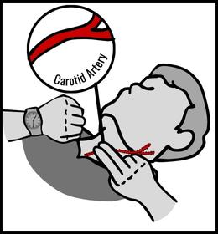
    - Conscious patient: to get the pulse of a conscious adult patient, use your first two fingers to find the radial pulse (located on the wrist). Once the pulse has been found, count the beats for 30 seconds. After 30 seconds, multiply the number by 2.
    - Unconscious patient: the pulse location for an unconscious patient is the Carotid artery, located on the neck next to the windpipe. Once the pulse has been found, count the beats for 30 seconds. After 30 seconds, multiply the number by 2.

Stingray Preventions/Treatment
Long Beach is a stingray habitat. Lifeguards regularly give stingray advisals and must know the proper treatment in the case of encountering a stingray patient.
- Prevention: beachgoers should enter the water by shuffling their feet along the sand. This disrupts the sand and gives stingrays a chance to get out of the way.
  - Stingray activity is higher during low tide, beachgoers should take extra care when entering and exiting the water.
- Treatment: placing the wound in water as hot as the patient can stand until the pain subsides (45 min-1 hour)

Area Orientation
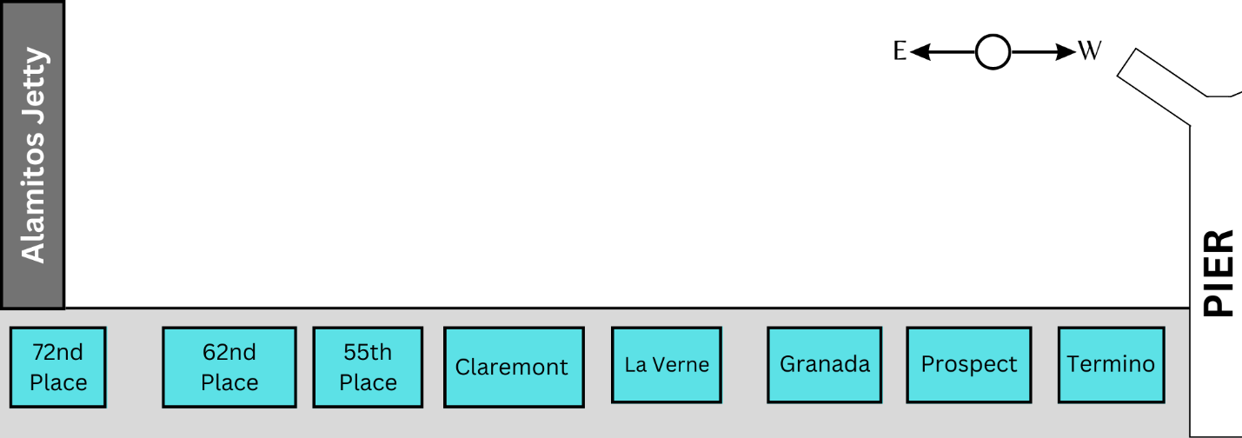
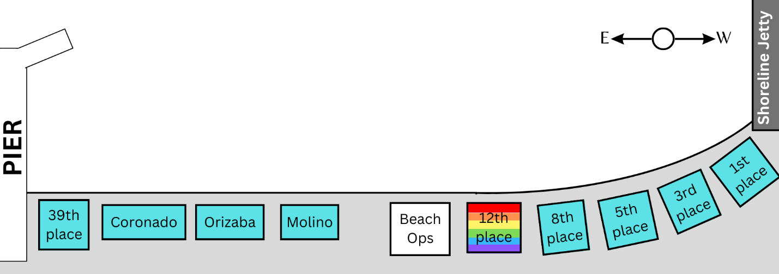
East Beach

